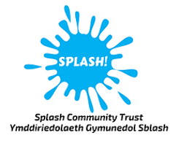
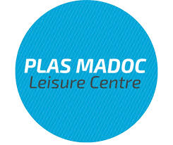
Community Hub
Support Surgery

A unique new drop-in event with multiple free services represented, come along and ask us how we can help you!

#AskTheSurgery!

When: Thursday 9th July
12:30pm – 2:30pm
Where: Plas Madoc Leisure Centre sports hall

