



Rhos Library, Princes Road, Rhos,
Wrexham, LL14 1AB.

01978 840328

Open until –
Monday & Friday – 6pm
Tuesday & Wednesday – 5pm

-

M

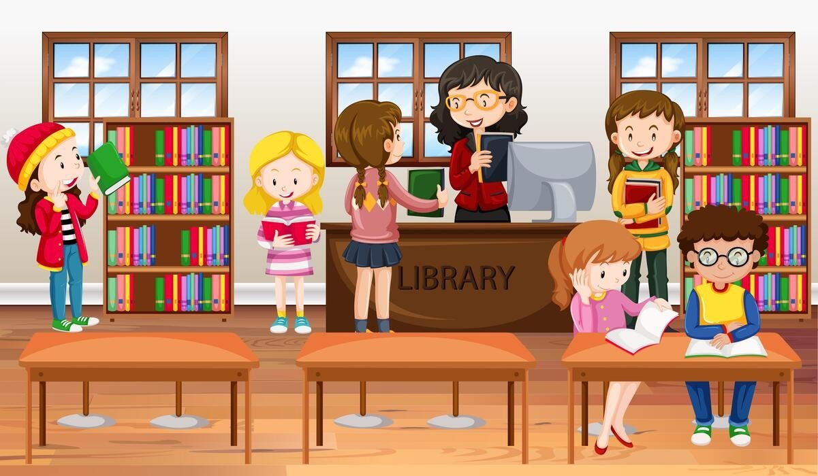
Did you know that you can visit the library in Rhos any time after school for you to do your homework. They have got lots of resources there that can help you!! Why don’t you pop down with your friends and see what they have to offer.

