All Stars After School club
Grand opening

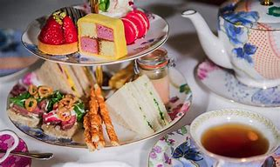
3.15pm – 5.30pm
To celebrate the opening of our new and exciting after school club room, on Tuesday 3rd November we will be hosting a ‘high tea’, tea party for those children who currently attend After School club. This will be an exciting opportunity for the children to explore all the new resources and settle in to their new room! Booking is essential as places will be limited.
The new room (Willow class) is located directly next door to the old room used. Entrance for parents will be through the same gate.
Contact Claire McBride on McBrideC1@hwbcymru.net to book your place.
Cost for the full session (Tuesday 3rd only) will be £4 per child.
We are looking forward to welcoming the children to our brand new room.
Many thanks
After school club staff x

