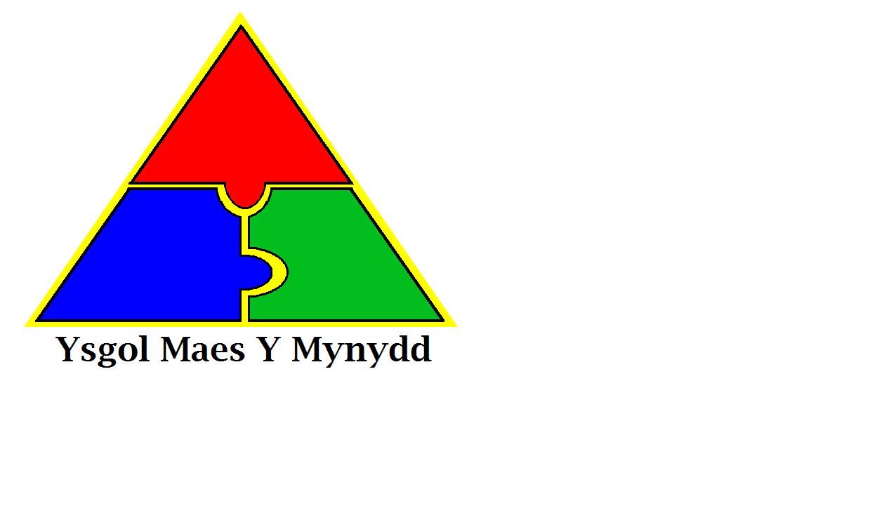

Ysgol Maes Y Mynydd

Pentredwr

Rhosllanerchrugog

Wrecsam  
LL14 1DD

Rhif Ffon: 01978 832970

Maes Y Mynydd School

Pentredwr

Rhosllanerchrugog

Wrexham  
LL14 1DD

Tel No: 01978 832970

**Weekly Newsletter Friday 27th April 2018**

**WCBC School’s Attendance Policy**

The above policy is available to view on the school website.

<https://maesymynydd.cymru/wp-content/uploads/2018/04/Attendance-Policy-December-2017.pdf>

**Holidays during term time**

Parents do not have an automatic right to withdraw pupils from school during the school term for a holiday. Under the Education (pupil registration) (Wales) Regulations 2010, Head Teachers have discretion to authorise a holiday of up to 10 days during term time, over 10 days can only be authorised in exceptional circumstances.

All requests for holidays must be completed on the schools holiday request form and completed by the parents/guardians (These are available from the main office).

The Head Teacher will make the decision and may include the following contributory factors:

* Time of year.
* Length of time.
* Overall percentage of attendance.
* Impact on the child’s learning.

**Attendance**

**Whole School Attendance**

16th April – 20th April – 96.14%

**Class of the Week**

16th April – 20th April

Class Pine – Mr McLaren – 99%





Is your daughter aged between 5 and 7 years old?

1st Rhos Rainbows meet every Tuesday (except School Holidays) at 5pm until 6pm in the top hall.

We run a variety of different activities linked to different themes.

The cost for Rainbows is £2 every week.

If you would like more information please come and speak to Mrs James in Cherry Class (Year 3).

**PLEASE BE AWARE** A few cases of chickenpox have been reported in school, please look out for the symptoms. Further information can be found on the school website <https://maesymynydd.cymru/wp-content/uploads/2017/09/Guidance-on-Infection-Control.pdf>

**Sports Days**

These dates are provisional and are dependent on the weather.

**Monday June 25th**

AM – Early Years

PM – Year 1/2

**Tuesday June 26th**

AM – 5/6

PM – 3/4

**National Tests Year 2 - 6**

These will be taking place on Wednesday, Thursday and Friday of next week.

**Health and Safety Reminder**

For Health and Safety reasons there is no driving/parking on the staff car park unless you are a blue badge holder even if the chain has been left off the gate.

We thank you for your help in keeping all children safe.

[](https://www.google.co.uk/imgres?imgurl=https://images.mydoorsign.com/img/lg/L/No-Dogs-Allowed-Symbol-Label-LB-1619.gif&imgrefurl=https://www.mydoorsign.com/NDS/No-Dog-Door-Signs.aspx&docid=blZoMgOYiOqMFM&tbnid=HTNIBlGndpRzBM:&vet=10ahUKEwjc7Pbf3rTaAhWBB8AKHeVgB-UQMwhOKBwwHA..i&w=400&h=400&safe=strict&bih=709&biw=1440&q=no%20dogs%20sign&ved=0ahUKEwjc7Pbf3rTaAhWBB8AKHeVgB-UQMwhOKBwwHA&iact=mrc&uact=8)

**Reminder – No Dogs**

Dogs are not allowed on school premises.

This includes dogs on leads or being carried. Please make sure you do not bring dogs onto the school yard at any time.

Thank you

**Year 4 – Swimming**

Swimming for Year 4 has been cancelled on Thursday 3rd May due to the National Tests taking place on this day.

**All Schools Concerts at the Stiwt Glee Club**

Juniors – 18th June 2018 at 7pm

Infants – 19th June 2018 at 2.15pm

**Summer Weather**

Now that the weather is getting warmer, when appropriate, please can you provide your child with a water bottle and sun hat? Children do spend time outdoors when in school and we recommend children have sun screen applied before coming to school in the morning. Water bottles can be bought from the main office for £1.00

**RESIDENTIAL TRIPS**

**Year 2**

Pentrellyncymer 14th – 15th May 2018

All payments/forms/proof of benefits due in immediately

**Year 4 & 5**

Nant BH 4th -6th June 2018

All payments due in by today, Friday 27th April



**NSPCC Workshops**

These will now take place on Monday 30/4/18

**Head lice reminder**

Can all parents please check your child’s hair for head lice regularly and treat accordingly. A few cases have been reported to school this week.

**Year 6 Transition to High School**

Grango transition will take place over 3 days. Wednesday June 27th – Friday June 29th.

If your child os not going to Grango you will receive information from the school directly.