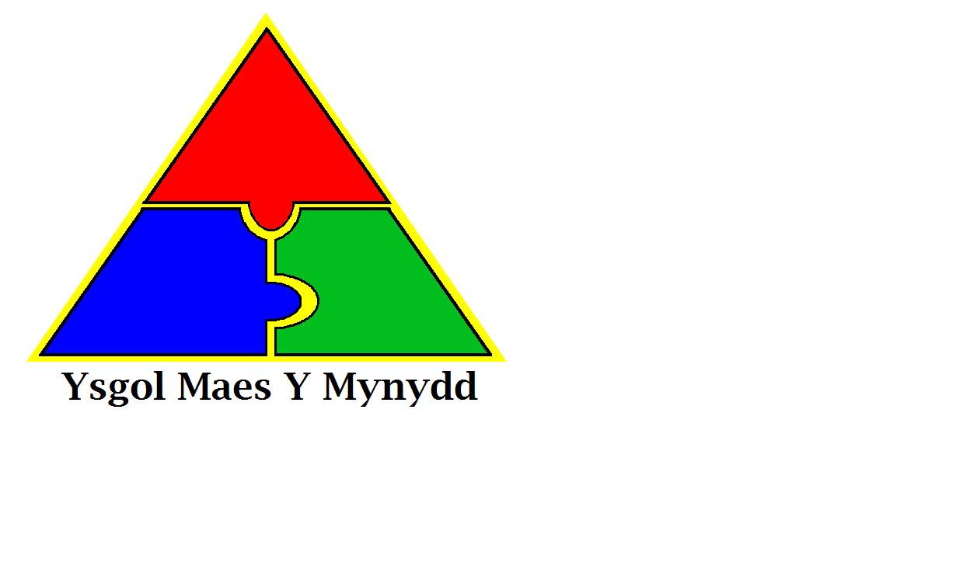

Ysgol Maes Y Mynydd

Pentredwr

Rhosllanerchrugog

Wrecsam  
LL14 1DD

Rhif Ffon: 01978 832970

Maes Y Mynydd School

Pentredwr

Rhosllanerchrugog

Wrexham  
LL14 1DD

Tel No: 01978 832970

**Weekly Newsletter Friday 20th April 2018**

**National Tests**

All pupils from years 2 – 6 will take part in national testing for reading and maths in May. All tests have to be completed between May 2nd and May 9th.

While we have to do the tests, we are trying to keep them as low key as possible and do not want to see the children getting upset and anxious.

We ask for your help in ensuring that your child is on time for school during the test period. Most classes will start the test as soon as registration is complete and if your child arrives late they will not be able to do the test at that time, this will be upsetting for them, as they will have to do them at a different time.

**RESIDENTIAL TRIPS**

**Year 2**

Pentrellyncymer 14th – 15th May 2018

All payments/forms/proof of benefits due in immediately

**Year 4 & 5**

Nant BH 4th -6th June 2018

All payments due in by Friday 27th April

**Attendance**

**Whole School Attendance**

19th March – 23rd March - 92%

**Class of the Week**

19th March – 23rd March

Class Silver Birch – Mrs Rawlings – 98%



**NSPCC Workshops**

Unfortunately the NSPCC Assemblies and workshops were cancelled this week.

We are waiting for confirmation of new dates from them and will let you know as soon as we get them.

**Planting Day**

**Friday 27th April**

Please can all children come in to school in old clothes and bring wellies/suitable shoes to change into for outdoor planting?

**Hot Weather**

The weather at the moment is very warm. Please can you provide your child with a water bottle and sun hat? Children do spend time outdoors when in school and we recommend children have sun screen applied before coming to school in the morning. Water bottles can be bought from the main office for £1.00

**All Schools Concerts at the Stiwt**

**Glee Club**

Juniors – 18th June 2018 at 7pm

Infants – 19th June 2018 at 2.15pm

**Health and Safety Reminder**

For Health and Safety reasons there is no driving/parking on the staff car park unless you are a blue badge holder even if the chain has been left off the gate.

We thank you for your help in keeping all children safe.

[](https://www.google.co.uk/imgres?imgurl=https://images.mydoorsign.com/img/lg/L/No-Dogs-Allowed-Symbol-Label-LB-1619.gif&imgrefurl=https://www.mydoorsign.com/NDS/No-Dog-Door-Signs.aspx&docid=blZoMgOYiOqMFM&tbnid=HTNIBlGndpRzBM:&vet=10ahUKEwjc7Pbf3rTaAhWBB8AKHeVgB-UQMwhOKBwwHA..i&w=400&h=400&safe=strict&bih=709&biw=1440&q=no%20dogs%20sign&ved=0ahUKEwjc7Pbf3rTaAhWBB8AKHeVgB-UQMwhOKBwwHA&iact=mrc&uact=8)

**Reminder – No Dogs**

Dogs are not allowed on school premises.

This includes dogs on leads or being carried. Please make sure you do not bring dogs onto the school yard at any time.

Thank you

Last week’s Stars of the Week



