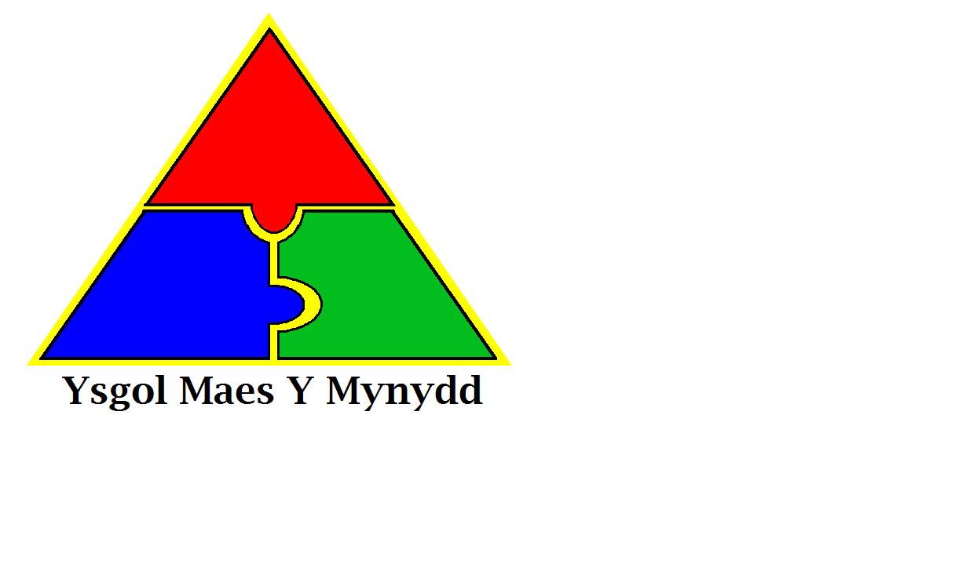

Ysgol Maes Y Mynydd

Pentredwr

Rhosllanerchrugog

Wrecsam  
LL14 1DD

Rhif Ffon: 01978 832970

Maes Y Mynydd School

Pentredwr

Rhosllanerchrugog

Wrexham  
LL14 1DD

Tel No: 01978 832970

**Weekly Newsletter Friday 13th April 2018**

**National Tests**

All pupils from years 2 – 6 will take part in national testing for reading and maths in May. All tests have to be completed between May 2nd and May 9th.

While we have to do the tests, we are trying to keep them as low key as possible and do not want to see the children getting upset and anxious.

We ask for your help in ensuring that your child is on time for school during the test period. Most classes will start the test as soon as registration is complete and if your child arrives late they will not be able to do the test at that time, this will be upsetting for them, as they will have to do them at a different time.

**RESIDENTIAL TRIPS**

**Year 2**

Pentrellyncymer 14th – 15th May 2018

All payments/forms/proof of benefits due in immediately

**Year 4 & 5**

Nant BH 4th -6th June 2018

All payments due in by Friday 27th April

**Attendance**

**Whole School Attendance**

19th March – 23rd March - 92%

**Class of the Week**

19th March – 23rd March

Class Silver Birch – Mrs Rawlings – 98%



**Non Uniform Day**

Friday 20th April will be a non-uniform day. Donations of 50p and/or a plant (flowers or vegetables) please.

We will be having a planting day on Friday 27th April so all donations would be gratefully received.

Thank you for your continued support.

**Term Dates 2018-2019**

The term dates for 2018-2019 have been uploaded to the website. The link is:-

<https://maesymynydd.cymru/wp-content/uploads/2018/02/term-dates-2018.2019.pdf>

**Swimming**

**Thursday 19/4/18**

There will be no regular swimming lessons on 19th April due to a swimming gala taking place at Wrexham Waterworld.

**All Schools Concerts at the Stiwt**

Juniors – 18th June 2018 at 7pm

Infants – 19th June 2018 at 2.15pm

[](https://www.google.co.uk/imgres?imgurl=https://images.mydoorsign.com/img/lg/L/No-Dogs-Allowed-Symbol-Label-LB-1619.gif&imgrefurl=https://www.mydoorsign.com/NDS/No-Dog-Door-Signs.aspx&docid=blZoMgOYiOqMFM&tbnid=HTNIBlGndpRzBM:&vet=10ahUKEwjc7Pbf3rTaAhWBB8AKHeVgB-UQMwhOKBwwHA..i&w=400&h=400&safe=strict&bih=709&biw=1440&q=no%20dogs%20sign&ved=0ahUKEwjc7Pbf3rTaAhWBB8AKHeVgB-UQMwhOKBwwHA&iact=mrc&uact=8)

**Reminder – No Dogs**

Dogs are not allowed on school premises.

This includes dogs on leads or being carried. Please make sure you do not bring dogs onto the school yard at any time.

Thank you

**Health and Safety Reminder**

For Health and Safety reasons there is no driving/parking on the staff car park unless you are a blue badge holder even if the chain has been left off the gate.

We thank you for your help in keeping all children safe.

**NSPCC**

We will be working with the NSPCC, the UK’s leading children’s charity, who’ll be delivering their Speak out, Stay safe programme on Thursday 19th April. This is a nationwide programme for every primary school aged child in the UK and Channel Islands. With the help of Buddy, their mascot, they’ll be presenting an assembly to the children as well as workshops for Years 5 and 6.





**Reception and Year 6 Class photos**

Tuesday 17/04/18

Please make sure your child is wearing their full uniform and if possible can they wear black socks?

Thank you

**Reception Admissions for Sept 2018**

If you have applied for a place in Reception, you should be informed by Monday 16th April if you were successful.

Please contact Admissions in Wrexham on 298991 if need further information.

**Nursery Open Afternoon**

Tuesday 17/4/18

1.15pm – 2.15pm

If you have children who are due to start Nursery in September, please come and have a look.